Let’s denote O as the camera origin, p as the principle point on the image plane, x is the projected coordinated, X as the original point in 3D world and P as the original principle point lying on the same plane with X and this plane is parallel to the image plane.

We see that the triangles Opx and the triangle OPX are similar triangles. Therefore, the ratio between the edges should be equal, or  . Finally, the 3D coordinate is projected onto the plane as , where the third coordinate is omitted as the projected plane is 2D Euclidean frame. The projected coordinate point is thus derived as:



1. The case when u and v axis are parallel to x and y axis, respectively

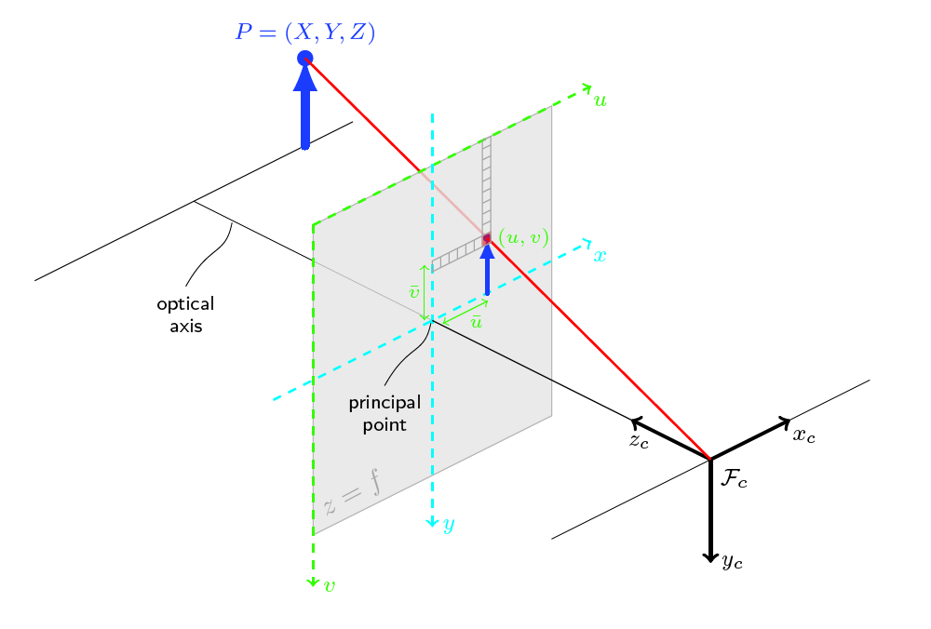

We can apply the same pinhole camera equation from Exercise 1, except now that the focal lengths should be expressed in terms of pixels, not in the unit length. We know that there areandnumber of pixels in each unit in their respective directions, so the focal lengths in pixels are and . Since the size of the pixels are not necessarily rectangular, the focal lengths in both direction will be different with the formula given above. Additionally, the principal point is no longer (0, 0) like in Exercise 1, but expressed as , so all pixel coordinates should be shifted by this principal point. Plugging into the equations, we have the pixel coordinate calculated from the camera coordinate and the focal length as:

(answer)

1. The case when u axis is parallel to the x-axis and the angle between u and v axis is

Since the image plane (pixel coordinate) is skewed with angle , the skewed projected coordinate is:

 =>  (answer)

From exercise (2), we have defined the equations for the UV coordinates. Sinceis homogeneous coordinates, it can be scaled by any factor. Since the z coordinate of is , will be scaled by:

 =>

We need to find such that. In the first row of , there isandbut no.In the second row, there isandbut no. In the third row, there is only . The coefficients are known and therefore, we can construct the intrinsic camera calibration matrix as:

 (answer). Plugging in, we have: or 

The extrinsic parameter calibration matrix is the concatenation of the rotation and translation matrices

. This translates the world coordinate to the camera coordinate

From exercise (3), the intrinsic paramter calibration matrix is 

The 3x4 camera projection matrix P that projects the world from world coordinates  to pixel coordinates can be formulated by multiply K and E together:

 (answer)

In other words, the projection from world coordinates to the pixel coordinates is:



1. The geometric derivation for the Rodrigues formula

The vector x can be decomposed into components parallel and perpendicular to the axis u as:

* 

The component parallel to u is the vector projection of x on u, which can be derived as:

* 

The component perpendicular to u is the vector rejection of x on u, which can be derived as:

* 

The component parallel to the axis does not change magnitude nor direction under rotation

* 

Only the perpendicular component changes its direction. Its magnitude, however, stays the same under rotation.

*  and  (1)

Because u and are parallel, their cross product is zero, which leads to:

* 

From (1), it follows as: . Finally, the fully rotated vector is:

(2). Substitute the identities and above into (2), we have:



1. Derive the expressions for the element of R as a function of  and u.

We have from part (a)

* 
* 

Extracting out the coefficients for each row, R can finally be derived as:

(answer)